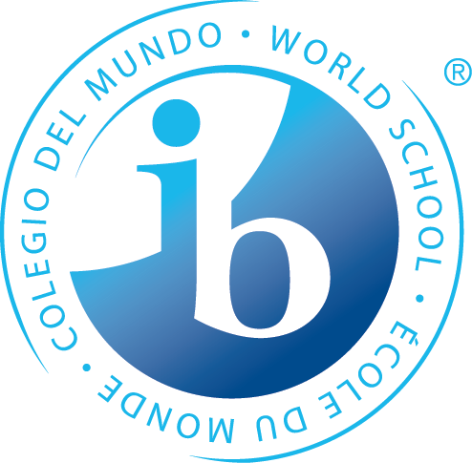
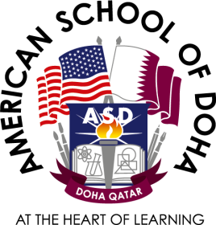

American School of Doha
HIGH SCHOOL IBDP Admissions Guide

Identity Statement
The American School of Doha is an independent, U.S. accredited, college preparatory school, committed to providing educational excellence, through a standards- based, internationally enriched American curriculum, serving a multicultural student body.
Mission
The American School of Doha is committed to the intellectual and personal development of our students, inspiring and empowering them to become positive, active global citizens.
Vision
ASD is a future-focused community where learning is... collaborative fun and engaging extended beyond walls creative to foster innovation sustained by responsible practices data-informed and evidence-based authentic, solving real-world problems encouraged in a technology-enhanced environment ASD is...where students are encouraged to extend their own learning
ASD Values
Honesty Honesty is expected from each person at ASD. Students display honesty by doing their homework, submitting their work for assessment and bringing to the teacher or school administration information about dishonest acts. Students who are dishonest will receive the appropriate consequence from the division administration.
Responsibility ASD students must take responsibility for their actions and behave appropriately at school and school events. The primary goal for ASD is to help students become caring, responsible citizens ready to contribute to society. Students display responsibility by doing their homework, coming to class on time, picking up after themselves and finding ways to make a positive contribution to the school and the community.

Compassion ASD students need to be compassionate to the needs of others. Students can display compassion by helping new students feel welcome, by respecting the opinions and ideas of others, and by volunteering time to a community service project. Students can display compassion by helping a classmate understand the homework - not allowing the classmate to copy the work, but by explaining the work so she/he is better able to understand the concepts being taught. It is very important that every ASD student and staff member display the ASD values on a regular, daily basis. If everyone works towards these values, ASD will continue to be a wonderful place to learn and grow.
Respect Respect is a cornerstone value, which every person at ASD must display. There are many ways to show respect. It is very important to listen and to try to understand the other person’s opinion and point-of-view. Students can show respect to teachers by arriving to class on time with all the needed equipment (notebook, calculator, textbook, etc.) ready to participate in class and learn. Students can be respectful of the school by adhering to the ASD values of Respect, Honesty, Responsibility, and Compassion

INTERNATIONAL BACCALAUREATE DIPLOMA PROGRAM (IBDP)

The International Baccalaureate Diploma Program(IBDP) is one of the academic programs offered at the American School of Doha (ASD). Although the IB Diploma Program is only available to students in Grades 11 and 12, the philosophy, methodology and Learner Profile of the IBDP greatly influences student learning throughout the entire school. Students who enroll in an IB Diploma Program are expected to write formal externally assessed IB exams in May.

The IBDP has grown substantially over the years with more students opting to complete the Full IB Diploma as well as Diploma Courses. This academic programme is inquiry based and is quite extensive in the range of skills that students must hone to be successful. It also supports the development of the whole child which is also a key feature at ASD. This program is an externally examined, assessed and moderated.

IB Subjects Courses Currently Offered

Group 1 - Studies in Language and Literature
- English Literature (HL/SL)
- English Language and Literature (HL/SL)
- Arabic Language and Literature (HL/SL)
- Spanish Language and Literature (HL/SL)

Group 2 - Language Acquisition
- French B (HL/SL) and Ab Initio (SL)
- Spanish B (HL/SL) and Ab Initio (SL)
- Arabic B (HL/SL) and Ab Initio (SL)

Group 3 - Individuals and Societies
- Economics (HL/SL)
- History (HL/SL)
- Psychology (HL/SL)
- Global Politics (HL/SL)

Group 4 - Experimental Sciences
- Biology (HL/SL)
- Chemistry (HL/SL)
- Physics (HL/SL)

Group 5 - Mathematics
- Mathematical Applications and Interpretations (HL/SL)
- Mathematical Analysis and Approaches (HL/SL)

Group 6- The Arts (Or an alternative choice from Group 1-4)
- Film (HL/SL)
- Theatre (HL/SL)
- Visual Arts (HL/SL)

Core Theory of Knowledge (TOK)
Creativity, Activity, Service (CAS)
Extended Essay (EE)

Full IBDP Diploma students must study one course from each of the six groups, three at Higher Level and three at Standard Level. Students may choose a second subject from Groups 1, 2, 3, 4 en lieu of a Group 6 subject; students may take the trans-disciplinary Group 3-4. In addition, all Full IB Diploma candidates must fulfil the three core requirements: Theory of Knowledge, Extended Essay, and CAS.

During our course selection process in Grade 10 all students are encouraged to access the full IBDP programme. We also offer the IBDP courses which is made accessible to all students. All students must meet the prerequisites for each subject that is determined by each department and is outlined in our High School Programme of Studies.. In addition the students social emotional needs are taken into consideration during the course selection process and is tracked throughout the two years of the programme by the IBDP Coordinator, Learning Support and High School Counsellors.

Students not wishing to pursue the full IBDP or IBDP Courses, have the option to select a hybrid combination of Advanced Placement courses and IBDP courses OR ASD courses and IBDP courses.

Apply to the American School of Doha IBDP Programme

When a candidate applies to the American School of Doha (ASD), we use our Mission, Vision, Values, Admissions policy as well as potential future university requirements to determine whether our school will be the right fit for the candidate and his/her family. We want to ensure that the student will have a successful experience at ASD and beyond.

Application Process for IBDP and IBDP Courses

ASD is open to receive applications from all candidates, regardless of race, gender, religion or ethnic background. Applicants will be screened and admitted or denied admission through the admissions process by the designated divisional Admissions committees. Qualified candidates are those that meet specific criteria as outlined, and will be accepted in accordance with the described priority sequence. The process will follow the same procedure with an addendum for students wishing to pursue the full IBDP or IBDP courses and will continue after an online application form has been submitted.

Step 1: The IBDP Coordinator will provide relevant information to prospective parents and students considering the IBDP and IBDP courses program with information outlining general expectations of the programme.

Step 2: The decision for entrance into the IBDP program will be based on a body of evidence including past performance, teacher recommendations, standardized test scores, writing sample and an interview with the IBDP Coordinator.

Step 3: The Admissions Committee and IBDP Coordinator will review all IBDP candidate applications, essays and recommendations. It is important to note that in the spirit of inclusivity and accessibility to the IBDP programme, the learning support department is involved in discussions and review of documentation with students that have been highlighted with Special Education Needs (SEN). This is to ensure that we are ably prepared to support the needs of our students and ensure they achieve their full potential.

Step 4: The student candidate will be invited to meet the IBDP coordinator to hear the results of the IBDP enrollment application. Further guidance will be provided for students and the family in alignment with the International Baccalaureate practice.

